Tasks To Be Performed:

1. Setup Puppet master-slave using 3 nodes

2. Installing Apache on slaves using manifests

**Procedure: -**

**Master-node**

1 sudo apt update  
 2 sudo apt install wget  
 3 wget https://apt.puppetlabs.com/puppet-release-bionic.deb  
 4 sudo dpkg -i puppet-release-bionic.deb  
 5 sudo apt update  
 6 sudo apt policy puppet master  
 8 sudo apt install puppet-master -y  
 10 sudo nano /etc/**default**/puppet-master //define this for the memory { #start puppetmaster on boot?

START=yes

JAVA_ARGS="Xms512m Xmx512m"}  
 11 sudo ufw allow 8140/tcp  
 12 sudo systemctl restart puppet-master  
 13 sudo nano /etc/hosts <10.0.11.53 puppet-master>  
 14 sudo mkdir -p /etc/puppet/code/environments/production/manifests  
 15 sudo puppet cert list  
 16 sudo puppet cert sign --all  
 17 cd /etc/puppet/code/environments/production/manifests  
 18 sudo nano site.pp  
 19 cd   
 20 cd /etc/puppet/code/environments/production/manifests  
 21 sudo nano site.pp  
 22 ls  
 23 sudo rm site.pp  
 24 ls  
 25 sudo nano site.pp  
 26 cd  
 27 history

**Client-node**

1 sudo apt **update**  
 2 sudo apt **install** wget  
 3 wget https://apt.puppetlabs.com/puppet-**release**-bionic.deb  
 4 sudo dpkg -i puppet-**release**-bionic.deb  
 5 sudo apt **update**  
 6 apt **policy** puppet **master**  
 7 sudo apt **install** puppet -y  
 8 sudo nano /etc/**hosts**  
 9 sudo systemctl **start** puppet  
 10 sudo systemctl **enable** puppet  
 11 sudo puppet **agent** --test  
 12 sudo puppet **agent** --test  
 14 sudo puppet **agent** --test  
 15 history

Site.pp

node default{  
  
$packages=['apache2','mysql-server']  
  
 package{$packages:  
 ensure=> installed,  
 }  
}

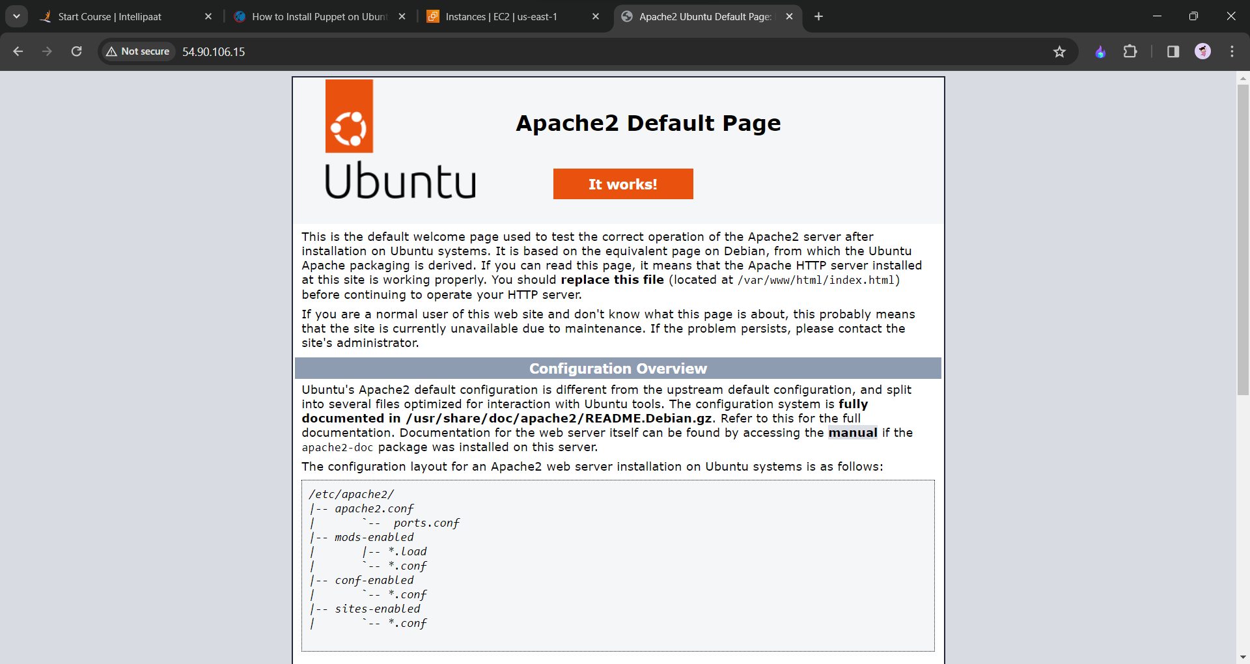

We will see the default page on the client-node public ip address.

# Define hostnames for slaves  
$slave1_hostname = 'slave1'  
  
# Define nodes  
node 'slave1' {  
 # Create file on slave1  
 **file** { '/temp/slave_info.txt':  
 ensure => present,  
 content => "This is $slave1_hostname\n",  
 }  
}